### **Project 01**

#### **Project Overview**

Your organization is implementing continuous integration (CI) practices to streamline the software development lifecycle. As part of this initiative, you will create a Jenkins declarative pipeline for building a simple Maven project hosted on GitHub. This project aims to automate the build process, ensure code quality, and facilitate continuous delivery (CD).

**Instructions**

1. **Setup Jenkins Job**
   * Create a new Jenkins pipeline job. Here we choose pipeline option.

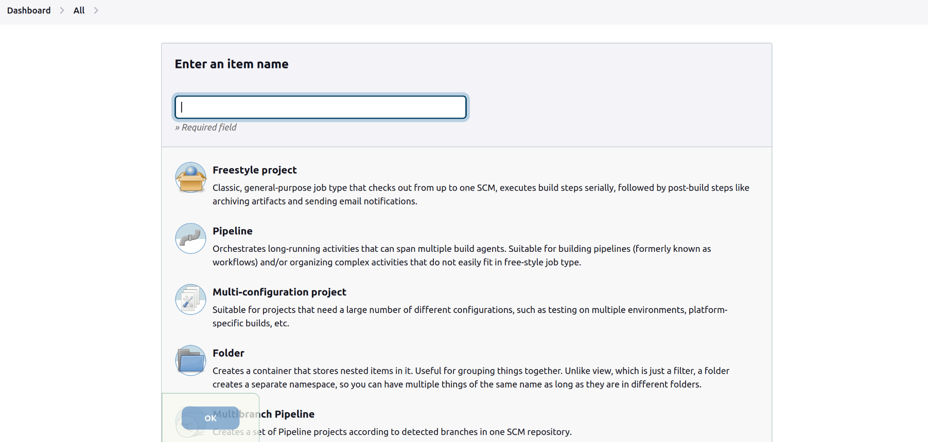

* + Configure the job to pull the Jenkinsfile from the GitHub repository.Tjough it is private repository we provide credentials.

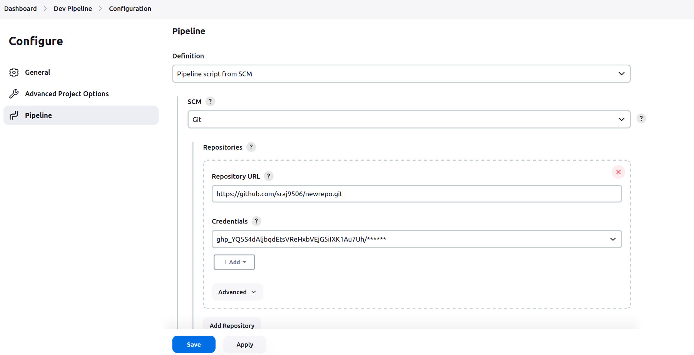

1. **Create Jenkinsfile**
   * Write a declarative pipeline script (Jenkinsfile) that includes the following stages:

1.Checkout

2.Build

3.Archieve Artifact

1. Checkout : for the checkout we have to provide credentials id because we are fetching java code from private repository.

2.Build: for the build we have to execute maven clean install command and therefore we have to provide path of maven and that’s why we use environment variable at the starting of file.

3.Archieve Artifact : Then after building the pipeline we archieve it on another location because by default it is stored in workspace which is volatile which means it remove previous build when we rebuild the pipeline.

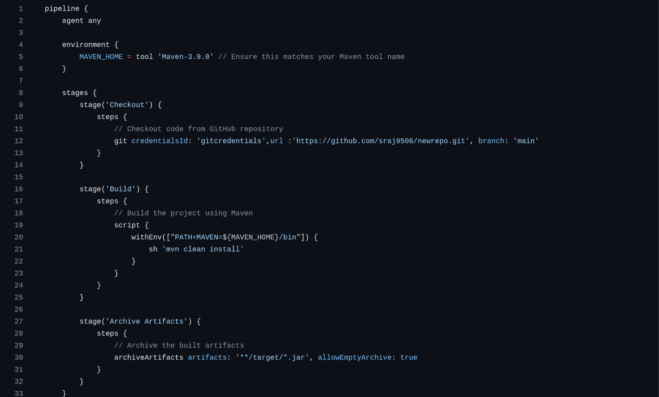

1. **Configure Pipeline Parameters**
   * Allow the pipeline to accept parameters such as Maven goals and options for flexibility.
   * Ensure the pipeline can be easily modified for different build configurations.
2. **Run the Pipeline**

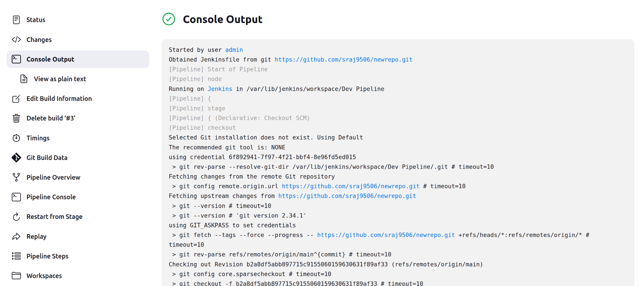

We can see in the output console that build is successfully finished.